Chase the Coach
This is a fun and educational drill for younger players. Line up all of your players side by side, each with his own ball. The coach should be standing five or 10 feet in front of the line of players, facing them. On the whistle, the coach begins to run in a zig-zag pattern, while the players must chase him while dribbling and keeping control of their balls. Their goal is to chase down the coach and hit him with a shot. This drill develops footwork and the ability to dribble through traffic because players will be crossing paths frequently
Read more: http://www.livestrong.com/article/301011-youth-soccer-drills-for-ball-control/#ixzz1BTGuBklt
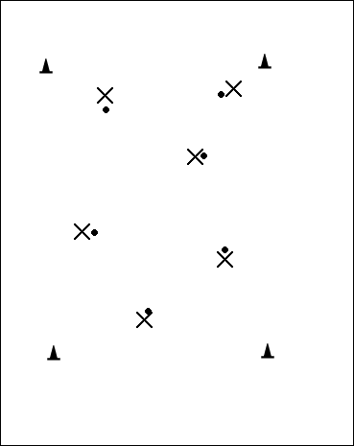
Nascar: fun dribbling drill for younger players
Set up- 4 -12 players in an area. Each with a soccer ball.
Coach yells "Ladies and Gentleman, start your engines". All players have to tap top of the soccer ball with the bottom of their cleat ten times.
Coach yells "first gear" --- players dribble their soccer ball slowly.
Coach yells "second gear" --- players dribble a little faster.
"third gear"-a little faster
"fourth gear" - as fast as they can.
"third gear" to "second gear" to "FOURTH GEAR" haha
If two players balls touch "CRASH" – five (or less depending on age or jumping jacks, Bev) push-ups outside circles
Coach can yell "reverse" everyone has to reverse their race car. Courtesy of www.coachingsoccer101.com

Mosquito
Note: This game can be used as either a Passing Game or a Shooting Game. This is a quite silly game that younger kids find really fun. Set the storyline by asking "Who knows what a Mosquito is?" After you see some raised hands, ask "What do Mosquitos do?" The answer you'll most certainly get is that they bite you! Well explain that they should pretend that the soccer ball is actually a mosquito, and that they get to use it to bite you, the coach (for some reason kids LOVE kicking the ball at the coach!).
The game starts by lining the kids up along one end line, each with their own ball. The coach starts at one end, about 10 feet in front of the end line, and then walks along in a line parallel to the players. The coach has their hands over their face, pretending to not see what is coming (I usually peak a bit to watch where I'm walking). Tell the players that when the coach is in front of them, take their best shot (or firm pass) at biting the coach by hitting them with the ball! Be sure to make funny noises when you get "bit"!
While the game is being played, stress proper technique, depending upon which skill you are working on (passing or shooting). Courtesy of www.soccerforcoaches.com

Flintstones.
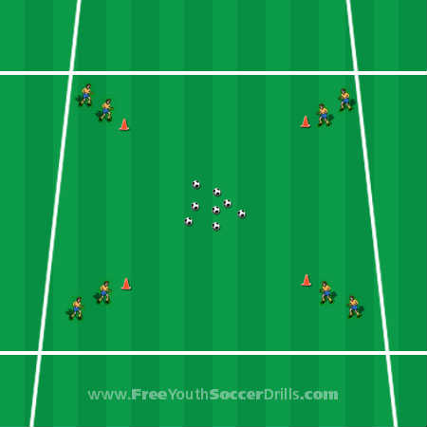
Preparation
Take a look at the diagram to the left. The players will be split up equally into the four corners as shown with soccer balls placed in the center.

Explanation
This drill is a competition of speed and accurate dribbling. The four separate teams from each corner will compete to get the most soccer balls back to their homes. Tell them that they are the Flintstones and they need rocks to build their homes stronger (which will be the balls).

On your command one person from each corner will run toward the center, collect a soccer ball and dribble it back to their starting point. Once all of the soccer balls have been collected count up the amount of balls and award a point to the team with the most.
The next game is the same but this time the players will dribble the ball into the middle, one at a time from each corner, and run back to their starting point until all the balls are back in the center.

Next, the players should do the same as the first game, however, this time when they collect a ball they must do the drag back turn. Demonstrate this turn with them.
"foot on top of the ball, roll the ball behind you, turn and follow the ball".
Keep playing this game throughout the season until you have covered many new turns such as the inside hook, outside hook, cruyff turn and step-over to name a few. (gauge your players ability and add new turns or just practice one, Bev)

Progression
A nice little way to end this game is by having a free-for-all collect and return game.
All the players run off at once to collect a soccer ball (only one at a time) and take it back to their starting point. They must keep going to others 'houses' to steal a ball and take it back to their own home.
The players are not allowed to take a ball that is being dribbled nor can they protect their own balls from being stolen.

Coaching Points
-> Make sure the kids use little touches and demonstrate what happens if you kick the ball too far in a game.
-> Make sure the kids use the inside and outside of their feet whilst dribbling - not their toes.
-> Demonstrate every turn that you use and show the players how this could work in a game situation

Courtesy of www.freeyouthsoccerdrills.com

HItters and Dodgers

Published 1/20/2007 12:25:16 PM

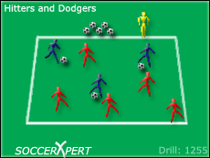
Drill Objective:
The Hitters and Dodgers soccer drill is a great warm-up and drill for younger players under 5 through under 9. This soccer drill is great for teaching players to dribble and then getting their heads up to make a pass. This soccer drill is SO much fun and the younger age group players LOVE this soccer drill.

Drill Setup:
With disk cones, outline a grid that is about 15X15 yards. You might want to make it a bit bigger or smaller depending on the age and number of kids you have. You will need to have a ball for each player; however, only 3 players start off with balls. The remaining balls should be placed outside the grid. The three players with balls are called the "hitters". The remaining players should start off scattered throughout the grid they are the "dodgers".

Drill Instructions:
Instruct the "hitters" to dribble inside the grid and attempt to pass the ball to any of the "dodgers" and hit them with the ball. The "dodgers" are attempting to avoid being hit by the "hitters". If a "dodger" is hit, he must collect a ball from the extra balls outside the grid and join the hitters. The last players standing win.

Drill Coaching Points:
Coaches should talk to the hitters about keeping their ball close to them while getting their heads up to find the dodgers.
Coaches should focus on good passing form: using the inside of the foot with good pace on the ball.

Drill Variations
Use a time limit instead and have a hit dodger take the ball become a new hitter allowing the hitter to play dodger, Bev

Courtesy of www.soccerxpert.com

Reminder: Players in this age group have very short attention spans. Do not allow any drill or game to run on too long. Do not keep doing the same thing over and over. You will find a list of great website that offer free drills and games for all ages, most divided by age and/or skill to teach. Make yourself a cheat sheet list of games and stick it in your pocket before practice. If you blank out on what to do next, instead of extending the current activity, call for a quick water break, look at your list to find something new to do. All teams have their favorite games and you may want to repeat that one frequently but ensuring that there is variety in every practice will keep the kids’ interest level up and make coach a little saner, Bev

