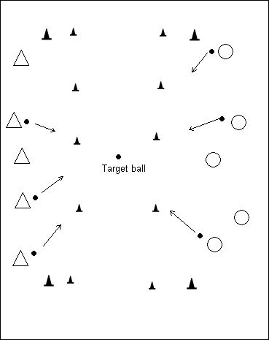
Tug of War – Push Pass
Setup- create four imaginary lines with cones. The inside lines about 20 yards. Put a unique colored soccer ball (target ball) in the middle.
Players on each side try make the target ball cross the opposing teams line by kicking (push passing) their soccer ball at the target ball.
Trains power and accuracy.
(*Adjust the distances from target ball according to age and ability. For older kids have them rotate on the fly from inside to outside cones, changing distances. Bev)
Courtesy of www.coachingsoccer101.com

Capture the Flag - Combines all types of soccer skills in a really fun contest.
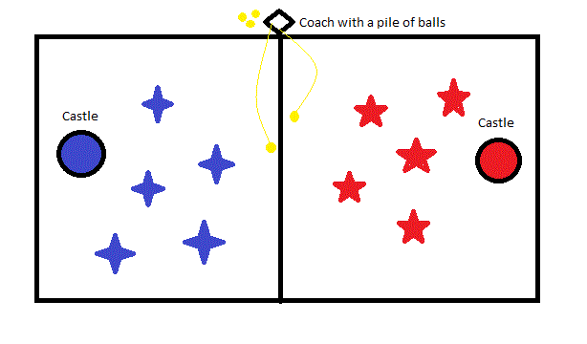
The size of the play area depends on the age level and number of players (I start with 20 x 30 yards for 5-year old players). At each end, form a circle about 8 feet in diameter with discs, placed just inside the play area. These circles represent the "castles". Split your team in half, forming two teams, using pinnies to tell them apart. If you want, you can quickly come up with team names by assigning them yourself or using the first one they call out. Each team starts at separate ends by their castle.
Gather all the balls you have (the more the better!), and collect them at midfield just outside one of the sidelines. The balls are the "flags", and the goal of the game is for each team to capture as many flags as possible and return them back to their castle.
The game begins with you or an assistant tossing or kicking a couple balls into the middle of the field. The teams will charge the balls and the game is on! As the teams successfully return the balls to their castle, throw more out. You'll soon have multiple "mini-games" going on at once. Keep it going until you are out of balls. Whichever team "captures the most flags" wins. A few points:
- The balls you have by the sideline may not be captured by the players until you put them in play.
- A ball is fair game all the way until it is safely secured inside a castle. This adds to the challenge as players must control the ball and stop it inside their circle. Players should be encouraged to steal from the opponent any balls that are not yet secured in a castle.
- Balls inside a castle are safe and may not be stolen.
- Mix up the way you put the balls in play. Throw some high ones out for your more advanced players, and roll some gently towards your more novice ones. Try to keep everyone involved! Courtesy of www.soccerforcoaches.com
Hurdles: for control
This drill develops ball control and dribbling. You need an even number of pylons and corresponding sticks. Place two pylons about two feet apart and place the stick across the top to create a hurdle. Ensure there is enough room under the stick for the ball to roll.(tall cones and yardsticks work well for this or bamboo canes from the garden section, they’re cheap, Bev) Put at least four hurdles in a row. Each player approaches the hurdle and must pass the ball under the hurdle, then jump the hurdle and recover the ball on the other side.
I used with with a team of 9 & 10 year olds and they loved it -- it's fun, develops ball control, and simulates dribbling in close quarters.
*Variation – For older players you can make this harder by varying the course, adding obstacles to dribble around, add speed…use your imagination.
Courtesy of www.eteamz.com

foxes and chickens. This game is exciting and gets the kids to change direction with the soccer ball at their feet.
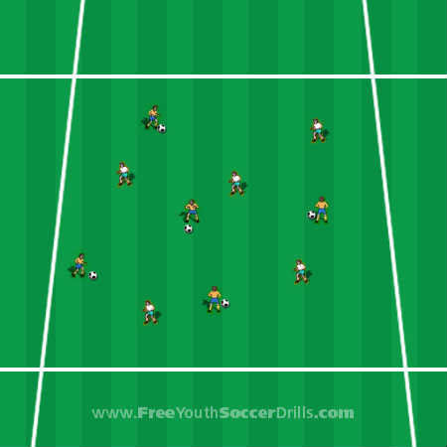
Preparation: Depending on the number of kids playing you will need to set-up a grid that the young players will not try and leave. You will need some pinneys, enough soccer balls for one-each and some helpful parents! (if you have older players, divide them into 2 teams instead of using parents & switch roles after first game)
Explanation : The aim for this soccer drill is for the young players to get the tail (pinney) from the parents. The parents act as the chickens and the kids are the foxes. The parents will have put a pinney half tucked into the back of their pants/shorts. The kids have to chase after them and remove the pinney (acting as a tail).
Progression: A useful progression to this drill is to play the first game without soccer balls and then introduce them into the second game. This will help the young players understand what they have to do. (probably not necessary with older players, Bev)
coaching points for younger players
-> Don't let the kids put their hands on the soccer ball
-> See if the kids can change direction by placing the bottom of their foot on the ball and rolling it behind them. This will eventually turn into the drag-back turn.
-> Get the kids to say with you 'oh no big toe' to encourage them not to use their toes to kick the ball.
(*Variation for older players – players with the flags should run at a decent pace. Encourage them to change direction often , zig and zag, fake ‘em out. As coach, you can every so often blow your whistle and instruct the players to pick someone else to chase forcing the player to change direction rapidly. To make it harder, instruct them what move to use when you blow the whistle. Bev) Courtesy of www.freeyouthsoccerdrills.com

